DHA-Website Layout
(revised)

Index
Structure / Linking
Start page
Navigation block
Section View
List View - rows
List View - grid
List Item - Event
List Item - Project
List Item - Biblio
List Item - Institution
Detail node view (#6198)
Detail - Event
Detail - Biblio
Detail - Project
Detail - Institution
Tags (#5170)
Tags as filter
Tags as Glossary

The digital-humanities.at website serves as a platform for information dissemination and exchange for the Austrian digital humanities community.
It is maintained and developed primarily by the Austrian Centre for Digital Humanities.
For more details about the overall application and development see redmine-Wiki

Structure / Linking

Page wise content loading
Paging should happen client-side, i.e. for given list all items are returned at once (no paging-parameters) (also because the API does not support explicit sorting.
Start page
List
View

[events, projects, resources, reading]
Detail
View
navigation
Submission form
[projects, events]
navigation

Start page
logo + the four main tiles, pointing to the corresponding list-views
Content from: https://dhdev.eos.arz.oeaw.ac.at/en/api_0_1/nodes?parameters[field_tags]=209


Navigation block
Content from: https://dhdev.eos.arz.oeaw.ac.at/en/api_0_1/nodes?parameters[field_tags]=214
Contains:
- Menu
- Language switch
- Search
- Tags

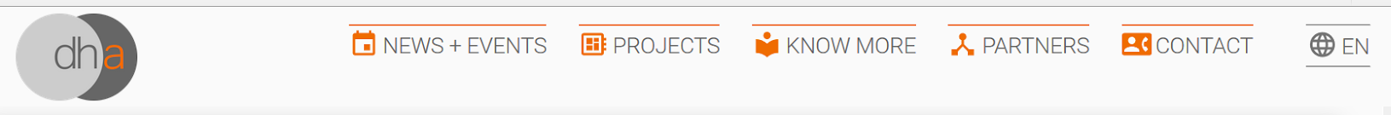

Section View
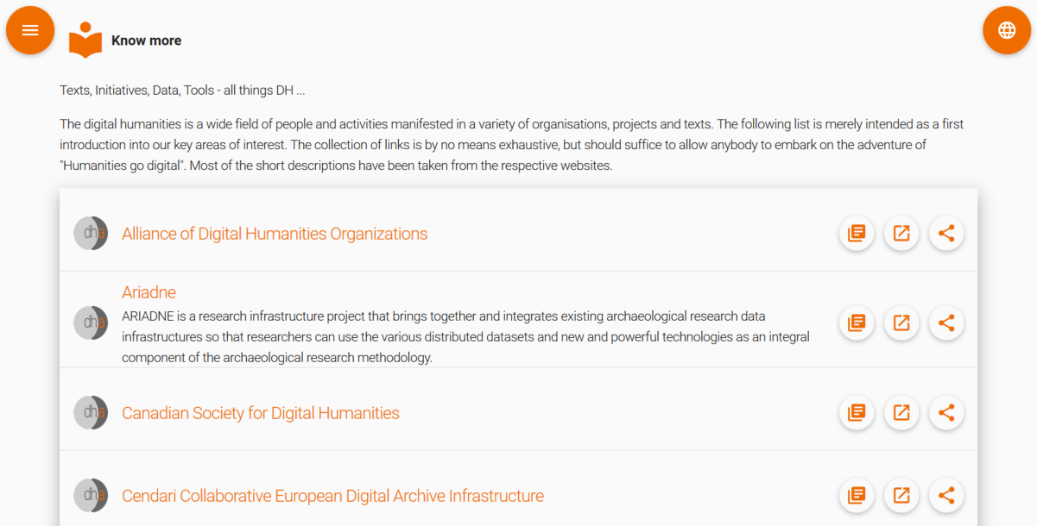

List View - rows
http://dhadevdesign.eos.arz.oeaw.ac.at/?page=Projects
Content for the list view is restricted by type, tags, or other query
Each item in the list has: Thumbnail, Title, Tags, Link, Teaser-text - This may need to be customized per type (see below)
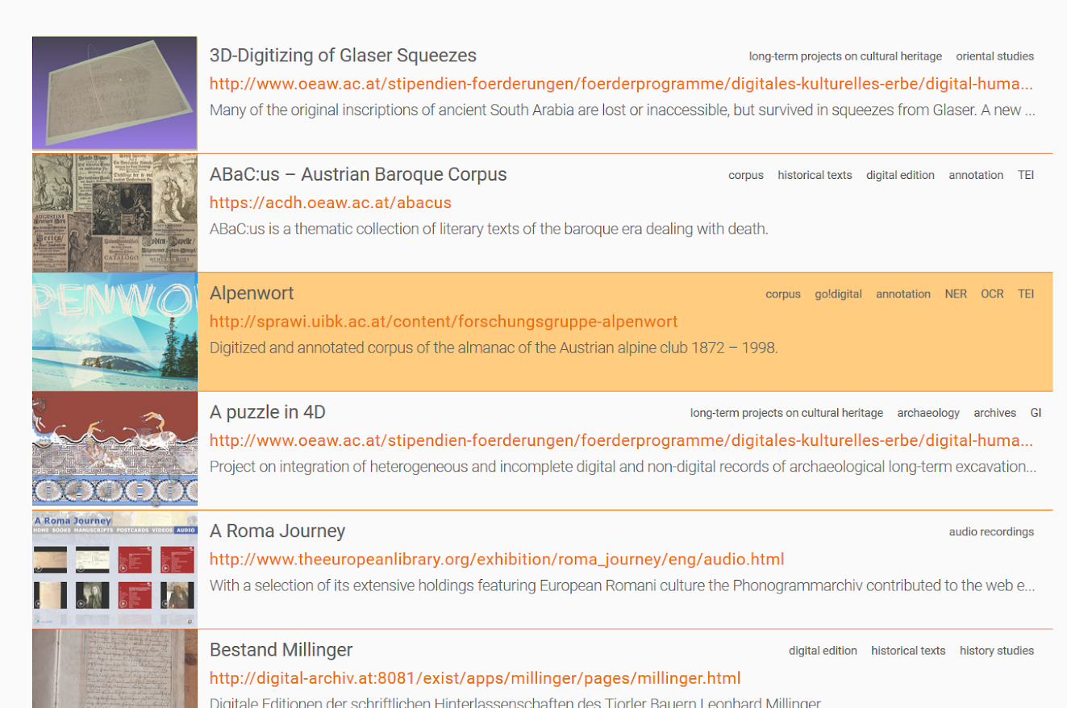

List View - grid
Each item should feature title, thumbnail, teaser
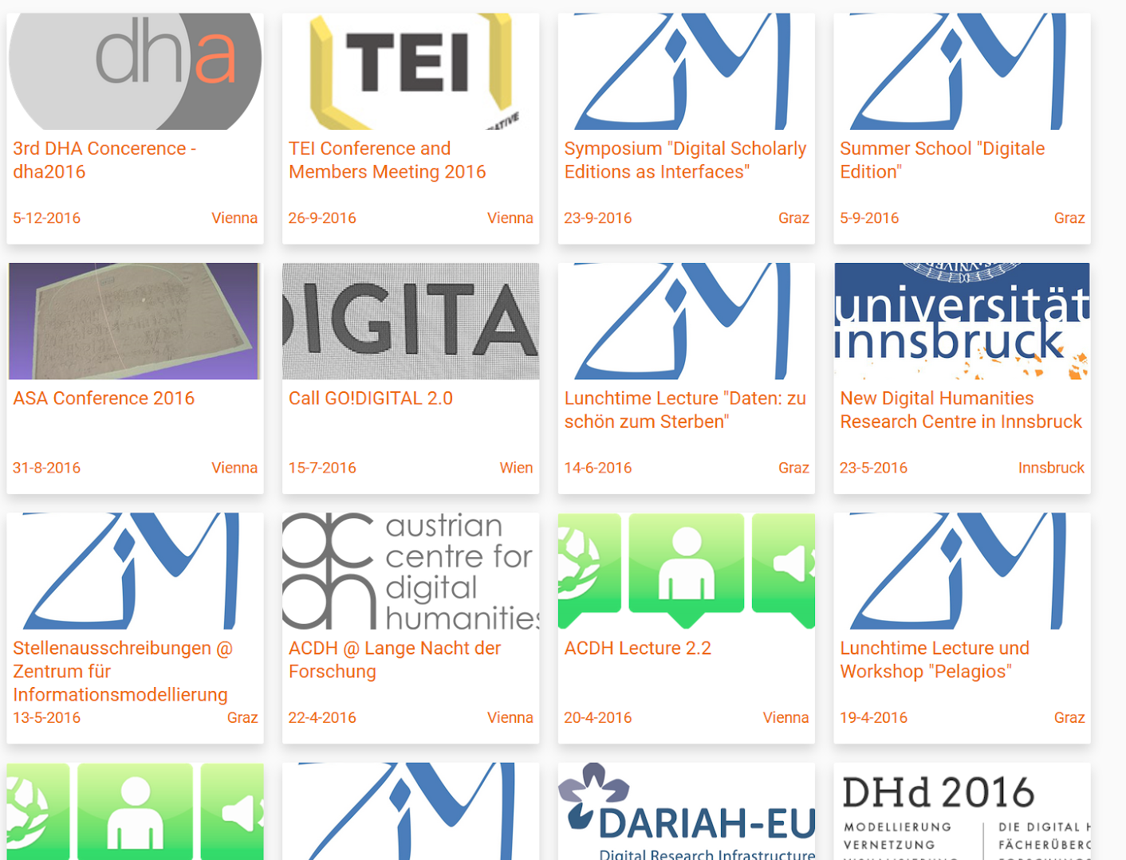

List Item - Event
List and grid

List Item - Project

List Item - Biblio

List Item - Institution

Detail node view (#6198)
(e.g.: http://dhadevdesign.eos.arz.oeaw.ac.at/?node=dha:993)
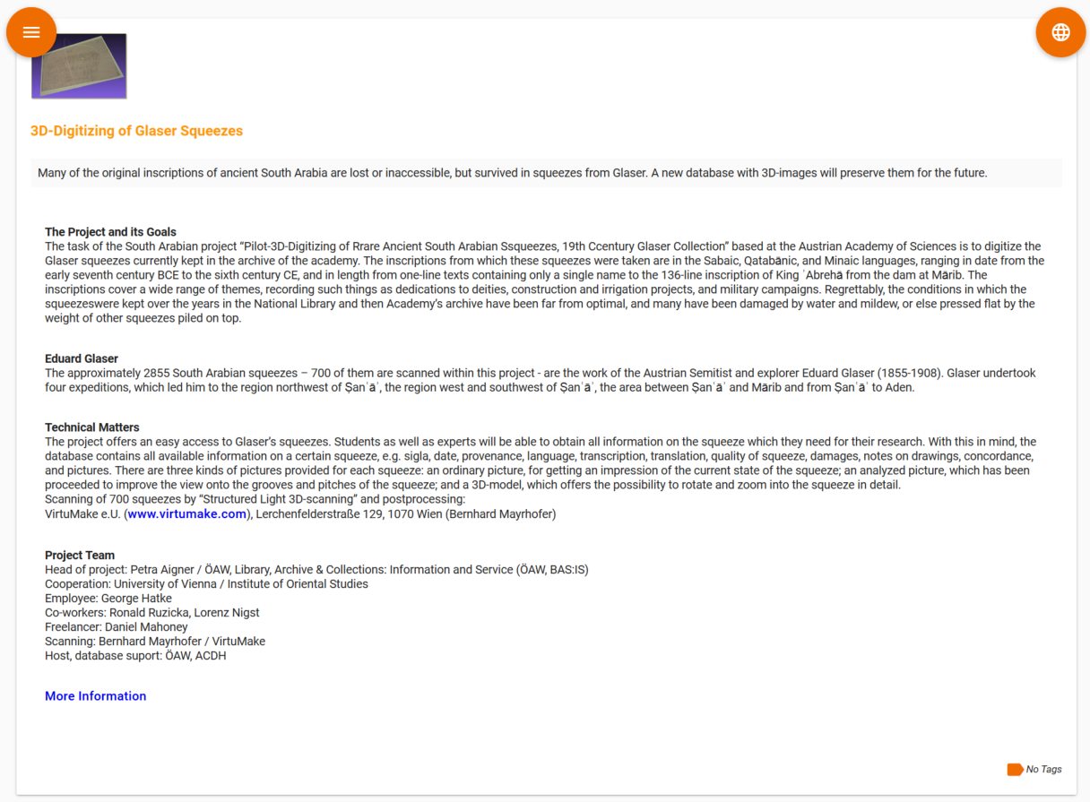

Detail - Event

Detail - Biblio

Detail - Project

Detail - Institution

Tags (#5170)
Tags serve mainly for filtering the content on the website,
But also as a glossary with definitions for the terms

Tags as filter
a complete (hierarchical) list of the tags as a separate block that pops-up as part of the navigation

Different views should be possible: html-tree, tag-cloud, graph

Tags as Glossary
Similar with tags in the navigation block, but not as filter, but full-page content (including explanations

